Invoice Payment Approval System — Business Requirements Document
26 October 2026 · Asif Shaikh

1. Document control
This BRD describes the invoice payment approval system as built and piloted in October 2026, so the company IT team can rebuild and host it on company servers.
Item | Detail
Version | 1.0 (draft for IT review)
Business owner | Finance / Accounts Payable, Mosaic Wellness
Prepared by | Asif Shaikh
Intended readers | Company IT team, Finance leadership, approvers (L1–L3), internal audit
Current pilot | https://mosaic-as.github.io/Payment-DashboardV2/ (GitHub Pages + Firebase + Google Workspace)
Source code | https://github.com/Mosaic-as/Payment-DashboardV2
Companion document | docs/IT-README.md in the repository: technical design, data model, APIs and migration plan
Approval of this BRD | Pending: Finance head, IT head

2. Executive summary and objectives
The system replaces email-and-spreadsheet invoice approvals with one web dashboard. It covers each step of a vendor invoice, from upload and checking through approval to payment with a UTR (bank transaction reference). Every step leaves an audit trail.
User 1 uploads and validates invoices and sends them in batches, one batch per expense category. Approvers L1 and L2 always approve. L3 approves only when a batch totals more than ₹20,00,000. Finance is then emailed automatically with the Excel and the invoice copies, and records a UTR, TDS and amount paid for each invoice.
Business objectives
# | Objective | Measure of success
O1 | One controlled channel for warehouse vendor invoices | 100% of warehouse invoices raised through the system
O2 | Enforce the approval matrix, including the ₹20 lakh rule for L3 | Zero payments without the required approvals
O3 | Catch data-entry errors before approval | Taxable + GST = total, GST rate, GSTIN, duplicates and dates checked on every invoice
O4 | Faster hand-off to Finance | Finance email within 1 minute of the final approval
O5 | Payment traceability per invoice | UTR, payment date, TDS and amount paid recorded per invoice
O6 | Audit-ready records | Who did what and when, kept for each invoice and batch; registers exportable at any time
O7 | Invoice copies filed consistently | Every copy stored in a folder for its service month

3. Scope
Scope is warehouse vendor invoices: capture through to payment recording. It excludes the payment itself, which Finance makes in the bank portal.
In scope
- Company single sign-on (Google Workspace, @mosaicwellness.in only) and admin-managed roles
- Vendor master (79 vendors loaded) with "add new vendor" from the invoice form
- Invoice capture with the copy shown beside the form, field checks and duplicate detection
- Invoice copies filed in Google Drive by service month
- Single and bulk sending, grouped into one batch per expense category
- Approval chain L1 → L2 → (L3 when the batch is above ₹20 lakh) → Finance
- Approval or return of single invoices inside a batch, and rejection of a whole batch
- Automatic email to Finance (To/CC set by an admin), sent from User 1's mailbox, with the Excel and PDF copies attached
- Per-invoice payment recording (UTR, date, TDS, amount paid), entered by hand or by bulk Excel upload
- Registers: Excel exports and a live Google Sheet
- Dashboard with counts and amounts by stage
Out of scope (this phase)
- Making payments or bank integration (no bank API, no payment file generation)
- Vendor onboarding, KYC, bank account master
- Purchase orders, GRN and three-way match
- TDS computation and returns (TDS amount is entered, not calculated)
- ERP / accounting system posting (for example Tally or SAP)
- OCR or automatic reading of invoice data
- Mobile apps (the web app works in a phone browser)
Assumptions
- Every user has a @mosaicwellness.in Google Workspace account.
- Each person holds exactly one role.
- Invoices are in INR, and one invoice has one expense category.
- Finance pays outside the system and then records the UTR in it.
Constraints
- Invoice copies are at most 10 MB each, as a PDF or an image.
- Gmail limits an email to 25 MB, so large sets of copies are split across several emails.
- The ₹20 lakh threshold and the category list are configuration values, changed only by IT/admin.

4. Stakeholders and user roles
Six roles exist and each user holds exactly one. The system enforces every permission below on the server, not only by hiding buttons.
Role (system code) | Who | Responsibilities
Invoice Maker — User 1 (maker) | AP executive | Upload invoices, add vendors, validate, send for approval, correct returned invoices. The finance email is sent from this user's mailbox.
Approver L1 — User 2 (approver1) | First-level approver | Approve, return or reject batches at L1
Approver L2 — User 3 (approver2) | Second-level approver | Approve, return or reject at L2. Final approver for batches up to ₹20 lakh.
Approver L3 — User 4 (approver3) | Senior approver | Approve, return or reject at L3. Only batches above ₹20 lakh reach L3.
Finance (finance) | Finance / treasury team | Receive the finance email, record UTRs per invoice, download the registers
Administrator (admin) | Finance head or IT | Manage users and roles, finance email recipients and the mailer address

Permissions matrix (✓ = allowed, — = not allowed)
Action | Maker | L1 | L2 | L3 | Finance | Admin
View dashboard, batches, invoices and registers | ✓ | ✓ | ✓ | ✓ | ✓ | ✓
Upload, edit or delete a draft invoice | ✓ | — | — | — | — | —
Add a vendor | ✓ | — | — | — | — | ✓
Validate an invoice and send it for approval | ✓ | — | — | — | — | —
Approve / return / reject at L1 | — | ✓ | — | — | — | —
Approve / return / reject at L2 | — | — | ✓ | — | — | —
Approve / return / reject at L3 | — | — | — | ✓ | — | —
Send or resend the finance email | — | — | ✓ | ✓ | ✓ | ✓
Record or correct UTR, TDS and amount paid | — | — | — | — | ✓ | —
Manage users and roles | — | — | — | — | — | ✓
Edit finance email settings | — | — | — | — | — | ✓

Segregation of duties: a user cannot change their own role, and an admin cannot demote or disable themselves. Only the user who validated an invoice can send it.

5. Process flow
Every batch passes L1 and L2. Only a batch totalling more than ₹20 lakh also needs L3 before it reaches Finance.
As-is pain points: approvals by email chains, invoice data re-keyed into spreadsheets, no single view of what is pending with whom, UTRs tracked outside the approval record, and invoice copies filed inconsistently.
To-be flow
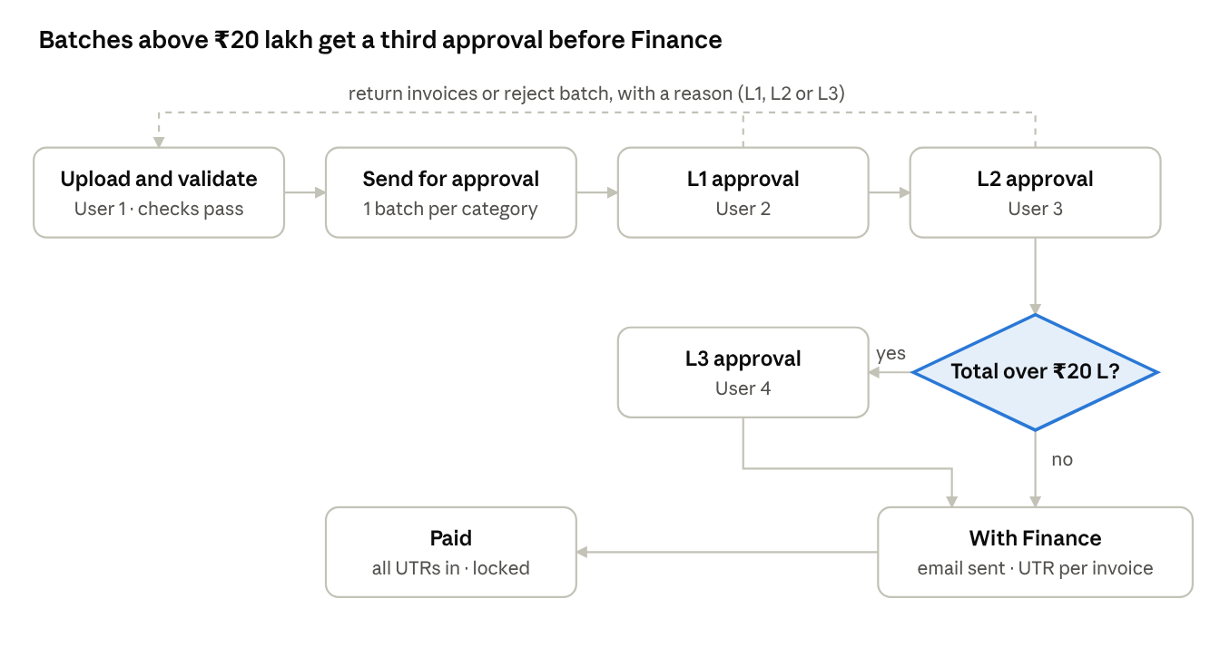
At any level the approver can approve all, approve or return single invoices, or reject the whole batch. Returned invoices go back to User 1 to be corrected and resent in a new batch.
Status lifecycle
Object | Statuses (in order) | Set by
Invoice | Draft → Validated → (in batch) Pending L1 / L2 / L3 → With Finance → Paid; or Returned → Draft | User 1, then derived from its batch and its payment
Batch | Pending L1 → Pending L2 → (Pending L3 if > ₹20 L) → With Finance → Partly paid (x/y) → Paid; or Rejected | Approvers, Finance, system

6. Functional requirements
All 52 requirements below exist in the pilot and must be carried over to the company-hosted version. Priority: M = must, S = should.
ID | Module | Requirement | Priority
FR-01 | Sign-in | Sign in only with Google Workspace SSO. Accounts outside @mosaicwellness.in are refused and signed out. | M
FR-02 | Sign-in | A signed-in user with no role, or a disabled user, sees "Access pending / disabled" and gets no data. | M
FR-03 | Users | Admin adds, edits, disables and removes users (email, name, role, active). | M
FR-04 | Users | Admin cannot demote or disable their own account. | M
FR-05 | Vendors | Vendor is chosen from a searchable dropdown (type part of a name, arrow keys and Enter). | M
FR-06 | Vendors | "+ Add new vendor" saves a vendor (name, optional GSTIN) for everyone. A differently written duplicate (e.g. "m/s liberal.") is recognised as the existing vendor. | M
FR-07 | Vendors | Choosing a vendor with a saved GSTIN fills the GSTIN field. | S
FR-08 | Vendors | An invoice can only be saved with a vendor from the list. | M
FR-09 | Invoice | Fields: vendor, GSTIN, invoice no., invoice date, expense category, service month, taxable, GST, total, invoice copy, notes. | M
FR-10 | Invoice | The invoice copy (PDF or image, max 10 MB) is chosen first and shown beside the form while data is entered. Text can be copied from text PDFs. | S
FR-11 | Invoice | Saving a new invoice puts it in Draft. Editing a validated or returned invoice puts it back to Draft. | M
FR-12 | Invoice | User 1 can delete an invoice only while it has never been sent, or after it was returned. | M
FR-13 | Storage | The copy is stored in Google Drive under <root>/<YYYY-MM (Month YYYY)>/, using the service month. The month folder is created automatically. | M
FR-14 | Storage | The file is named YYYY-MM - Vendor - InvoiceNo.ext. It is moved and renamed when the service month, vendor or invoice no. changes. | S
FR-15 | Validation | The checks in section 7 run live. Errors block validation; warnings must be acknowledged. | M
FR-16 | Validation | The Review & Validate screen shows the details beside the copy. Validate is enabled only after the "I have double-checked…" box is ticked. | M
FR-17 | Validation | After validation, a Send for payment approval button is offered at once. | M
FR-18 | Sending | User 1 can send one invoice, or select many and send them in bulk. | M
FR-19 | Sending | Sent invoices are grouped into one batch per expense category. A preview shows each batch's total and route before confirming. | M
FR-20 | Sending | Batch number format BYYMMDD-CAT-XXXX, e.g. B261024-ELEC-K1TK (CAT = the first letters of the category after "Warehouse -"). | S
FR-21 | Sending | On sending, an Excel file with a Batch Summary sheet and an Invoice Details sheet downloads. | M
FR-22 | Approval | Route: L1 → L2 → L3 only if the batch total is more than ₹20,00,000 → Finance. | M
FR-23 | Approval | Each approver sees a queue of the batches at their level only, with their total and route. | M
FR-24 | Approval | The batch screen shows a timeline (sent, L1, L2, L3 or "not required", Finance), the invoices with their copies, and returned invoices. | M
FR-25 | Approval | Approve all moves the batch to the next level. Comment is optional. | M
FR-26 | Approval | The approver can tick invoices and Approve N. The batch moves on once every invoice left in it is approved ("Approve remaining N"). | M
FR-27 | Approval | The approver can tick invoices and Return N to User 1 with a mandatory reason. The batch's total and the ₹20 lakh route are recalculated, and the batch stays at the same level. | M
FR-28 | Approval | Reject batch with a mandatory reason returns all of the batch's invoices to User 1. | M
FR-29 | Approval | Before approving, the system re-adds the invoice amounts and blocks approval if they don't match the batch total (integrity check). | M
FR-30 | Returns | A returned invoice shows as Returned, with the approver, level and reason. User 1 corrects it, validates it again and sends it in a new batch. | M
FR-31 | Finance email | At the final approval, Finance is emailed automatically (content in section 9). | M
FR-32 | Finance email | The email is sent from User 1's mailbox. Recipients come only from the admin settings. | M
FR-33 | Finance email | The batch shows whether the email was sent (who, when) or failed (with the error). L2, L3, Finance and admin can Resend. | M
FR-34 | Finance email | Each batch is emailed only once unless someone clicks Resend. | M
FR-35 | Payments | Finance records a UTR, payment date, TDS and amount paid for each invoice. | M
FR-36 | Payments | ⬇ UTR template downloads an Excel of every unpaid invoice in approved batches, with a hidden reference column and an Instructions sheet. | M
FR-37 | Payments | ⬆ Upload UTRs reads the filled template and previews ready rows, problems (with row numbers) and warnings. Only the ready rows are saved, and only after confirmation. | M
FR-38 | Payments | Rows without a UTR are ignored, so a partly filled template can be uploaded. | M
FR-39 | Payments | The batch screen has an Enter payments table for entering or correcting UTRs by hand. | M
FR-40 | Payments | A batch shows "Partly paid (x/y)" and becomes Paid when every invoice has a UTR. A paid batch is locked. | M
FR-41 | Payments | Several invoices of the same vendor may share one UTR. The same UTR on different vendors is warned about. | M
FR-42 | Reports | Excel downloads: per batch, filtered batches, the full payment register, and all batches ready for payment. | M
FR-43 | Reports | A Google Sheet is rewritten after every change, with the tabs All Invoices, Sent for Payment and Batches. | S
FR-44 | Dashboard | Counts and amounts by stage: draft, validated, returned, pending L1, L2 and L3, with Finance, paid this month. Also in-flight amount by category. | S
FR-45 | Dashboard | An All batches register with status and category filters, and the full approval trail of each batch. | M
FR-46 | Settings | Admin sets the finance email To and CC lists and the mailer URL, and can Send test email to me. | M
FR-47 | Audit | Each invoice keeps a history (uploaded, edited, validated, sent, with user and time). Each batch keeps its approvals, returns, payments and email outcome. | M
FR-48 | Audit | Batches can never be deleted. The approval history can only grow. | M
FR-49 | Usability | Errors are shown in plain words, with the system's error code. Saves time out after 30 seconds with a message. | S
FR-50 | Usability | Dialogs fit the screen. On narrow screens the copy and the form stack vertically. | S
FR-51 | Usability | All amounts are shown in ₹ with Indian digit grouping (₹1,23,45,678.00). Dates are shown as DD Mon YYYY. | M
FR-52 | Demo | Without a server configuration the app runs in a browser-only demo mode, for training. | S

7. Business rules and validation rules
The business rules must be enforced on the server; the browser checks are for convenience only.
Business rules
ID | Rule
BR-01 | L3 approval is needed only when the batch total is strictly greater than ₹20,00,000. Exactly ₹20,00,000 does not need L3. The threshold is configurable.
BR-02 | The L3 decision is made on the batch total, never on single invoices. It is recalculated whenever invoices are returned out of a batch.
BR-03 | One batch per expense category per send. A batch can't be edited after sending except by an approver returning invoices.
BR-04 | Approvals are strictly sequential. Only the role for the batch's current level can act on it.
BR-05 | A return or a rejection must have a reason, and the reason is shown to User 1.
BR-06 | An invoice in an active batch (pending, with Finance or paid) can't be edited or deleted.
BR-07 | Only the user who validated an invoice can send it, and any edit requires validating again.
BR-08 | The finance email goes out at the final approval: L2 when the batch is ≤ ₹20 L, L3 when it is > ₹20 L.
BR-09 | Amount paid + TDS must not exceed the invoice total by more than ₹1. A shortfall of more than ₹1 is allowed, with a warning.
BR-10 | Amount paid defaults to invoice total − TDS. TDS defaults to 0.
BR-11 | A batch is Paid only when every invoice in it has a payment. After that, payments are locked.
BR-12 | The registers and the Excel files show the same columns. The Google Sheet is a copy; the database is the source of truth.

Invoice validation
Check | Result | Message shown
Vendor, invoice no., date, category, service month, copy present | Error | "… is required"
Vendor in the vendor list | Error | "Pick it from the dropdown, or choose + Add new vendor"
Taxable, GST, total are numbers ≥ 0 with at most 2 decimals, total > 0 | Error | "… must be a number / cannot be negative"
|Taxable + GST − Total| > ₹1 | Error | "Taxable + GST = X, which does not match Total"
Difference between ₹0.01 and ₹1 | Warning | "Round-off difference of ₹x"
Effective GST rate not within 0.1% of a slab (0, 0.25, 3, 5, 12, 18, 28, 40%) | Warning | "Effective GST rate is x%, not a standard slab"
GSTIN present but not in the format ^\d{2}[A-Z]{5}\d{4}[A-Z][1-9A-Z]Z[0-9A-Z]$ | Error | "Vendor GSTIN format is invalid"
GST > 0 and GSTIN blank | Warning | "GST is charged but vendor GSTIN is blank"
Invoice date in the future | Error | "Invoice date cannot be in the future"
Invoice date older than 180 days | Warning | "Invoice is N days old"
Service month in the future | Warning | "Service month is in the future (advance billing?)"
Same vendor + invoice no. already exists (case, spaces and punctuation ignored) | Error | "Duplicate: invoice … from this vendor already exists"
File larger than 10 MB, or not a PDF or image | Error | "Attachment is larger than 10 MB"

Payment (UTR) validation
Check | Result
UTR is 12–22 letters and digits (IMPS/UPI 12, NEFT 16, RTGS 22), converted to upper case | Error if not
Payment date valid and not in the future (accepts DD-MM-YYYY, DD/MM/YYYY, YYYY-MM-DD and Excel dates) | Error if not
Payment date before the invoice date | Warning
TDS ≥ 0 and amount paid > 0 | Error if not
Invoice not found, not with Finance, already paid with a different UTR, or listed twice in the file | Error (row skipped)
Same UTR used for a different vendor | Warning

8. Data requirements
The system holds eight entities. The full field-level schema, with a PostgreSQL design for the company server, is in docs/IT-README.md.
Entity | Key fields | Notes
User | email (ID), name, role, active | Admin-managed; email is lower case and must be on @mosaicwellness.in
Vendor | name, GSTIN, created by, created at | 79 vendors loaded at start; others added from the invoice form; duplicates matched ignoring case, spaces and punctuation
Invoice | vendor, GSTIN, invoice no., invoice date, category, service month, taxable, GST, total, notes, file (Drive ID, name, link), status (Draft or Validated), batch, created by/at, validated by/at, history | Its stage (Returned, Pending L1…, Paid) is worked out from its batch
Batch | batch no., category, invoice list, count, taxable/GST/total, needs L3, status, approvals, invoices approved one by one, returned invoices, payments, finance email outcome, created by/at, paid by/at | Statuses: Pending L1, Pending L2, Pending L3, With Finance, Paid, Rejected
Approval (within a batch) | level, by, at, decision (Approved or Rejected), comment | Append-only
Returned invoice (within a batch) | invoice, invoice no., vendor, amount, level, by, at, reason
Payment (per invoice, within a batch) | UTR, payment date, TDS, amount paid, recorded by, recorded at | Can be corrected until the batch is Paid
Settings | finance email To list, CC list, mailer URL | Admin only

Expense categories (16): Warehouse - Repairs, Conveyance, Fixed Assets, Other Consumables, Printing Stationery, Internet, Electricity, Manpower, Security & Housekeeping, Loading/Unloading, Transportation, Rent, Packaging (Consume), Machinery Rent, Staff Welfare, Subscription.
Retention: invoices, batches, approvals and payments must be kept for at least 8 years (Companies Act / GST record-keeping). Nothing is hard-deleted after an invoice is sent.

9. Notifications: the finance email
One email goes to Finance per batch, the moment the final required approval is given. It is sent from User 1's mailbox, with the Excel and every invoice copy attached.
Item | Specification
Trigger | Batch moves to With Finance: after L2 when the total is ≤ ₹20 L, after L3 when it is > ₹20 L. Also triggered when approving the last ticked invoice, or by a return that leaves only approved invoices.
Sender | User 1's mailbox, display name "Invoice Payment Approvals"
To / CC | Finance team / stakeholders, maintained by an admin under Settings
Subject | Payment approved – <Batch no> · <Category> · ₹<Total> · <N> invoices
Attachments | <Batch no>.xlsx (Batch Summary and Invoice Details sheets) + every invoice copy, named <Vendor> - <Invoice no>.pdf
Size limit | If the attachments go over about 17 MB, the rest of the copies follow in emails titled "… – invoice copies part 2 of N". The main body is unchanged apart from one closing line saying more copies follow. No Drive links are put in the body.
De-duplication | One email per batch; another only when someone clicks Resend
Failure | The batch shows "Finance email not sent" with the reason. L2, L3, Finance or admin can resend it. The approval itself is never blocked.

Email body, in order
- Greeting and one line: the batch has completed all approvals and is ready for payment.
- Batch summary: batch no., expense category, no. of invoices, taxable total, GST total, batch total, approval route.
- Approval trail: sent by User 1 (name, date and time); L1 and L2 approver with date, time and comment; L3 approver, or "Not required (batch ≤ ₹20.00 L)".
- Invoice table: #, vendor, GSTIN, invoice no., invoice date, service month, taxable, GST, total, with a totals row.
- Returned to User 1 (only if any): invoice no., vendor, amount, reason.
- Attachments line and a link to the Payment queue.
- Footer: automated email from the dashboard.

10. Reports and exports
The same column layout feeds every Excel download and the Google Sheet, so the figures always match.
Report | Where | Content
Batch Excel (on send) | Downloads automatically when User 1 sends | Batch Summary + Invoice Details for the batches just created
Batch Excel | Any batch screen, ⬇ Excel | The same, for one batch
Payment register | All batches → ⬇ Payment register | Every batch ever sent, excluding rejected ones
Filtered batches | All batches → ⬇ Excel (filtered) | Batches matching the status or category filter
Ready for payment | Payment queue → ⬇ Excel of batches | All batches with Finance
UTR template | Payment queue → ⬇ UTR template | Every unpaid invoice with empty UTR, date, TDS and paid columns + an Instructions sheet
Google Sheet | Top bar 📊 Sheet link | Tabs All Invoices, Sent for Payment and Batches, rewritten after every change

Batch Summary columns: Batch No, Expense Category, No. of Invoices, Taxable Total, GST Total, Batch Total, Approval Route, Status, Sent By, Sent At, L1/L2/L3 Decision, By, At and Comment, Invoices Paid, TDS Total, Amount Paid Total, Fully Paid At, Returned Invoices.
Invoice Details columns: Batch No, Expense Category, Service Month, Vendor Name, Vendor GSTIN, Invoice No, Invoice Date, Taxable Amount, GST Amount, Total Amount, Notes, Uploaded By, Validated By, Validated At, Batch Status, UTR, Payment Date, TDS, Amount Paid, Invoice Copy (link).
All Invoices (Sheet) adds: Status, Uploaded At and Return Reason, so it also lists drafts and returned invoices.

11. Non-functional requirements
The hosted version must enforce every permission and business rule on the server; the pilot does this through Firestore security rules.
ID | Area | Requirement
NFR-01 | Authentication | Google Workspace SSO (OIDC), restricted to the @mosaicwellness.in domain (hd claim + verified email). No local passwords.
NFR-02 | Authorisation | Role checks on every API call on the server. The browser is never trusted for role, amounts, totals or the L3 decision.
NFR-03 | Integrity | The server recalculates batch totals from the invoices; it never accepts a total sent by the browser. The L3 flag is derived on the server. (The pilot checks this in the approver's browser; see section 14.)
NFR-04 | Audit | Every state change is written to an append-only audit log (user, time, action, before/after). Batches are never deleted.
NFR-05 | Data protection | Invoice copies are reachable only by signed-in users with a role. HTTPS everywhere; data encrypted at rest; data hosted in India (pilot: asia-south1, Mumbai).
NFR-06 | Performance | Pages load in under 3 s on office broadband. A 100-invoice batch can be sent, approved and paid without errors (tested in the pilot's rules). UTR upload of 500 rows previews in under 5 s.
NFR-07 | Capacity | About 2,000 invoices a month and 20 concurrent users, with headroom of 10×.
NFR-08 | Availability | 99.5% during business hours (Mon–Sat, 9:00–21:00 IST). Daily backups, 30-day point-in-time restore.
NFR-09 | Retention | At least 8 years for invoices, copies, approvals and payments.
NFR-10 | Usability | Works in current Chrome and Edge; usable on a 1366×768 laptop; on a phone the layout stacks.
NFR-11 | Email | The finance email goes out within 1 minute of the final approval. A failure is visible and can be retried.
NFR-12 | Observability | Server logs for sign-ins, approvals, payments, email sends and errors, with alerts on failed emails and sync jobs.
NFR-13 | Maintainability | Threshold, categories, vendor list, recipients and roles are configuration or admin data, not code changes.

12. Integrations and target hosting
The recommended rebuild keeps the React screens and moves every rule into one API service on a company server. Google Workspace stays for sign-in, invoice copies, the finance email and the register.
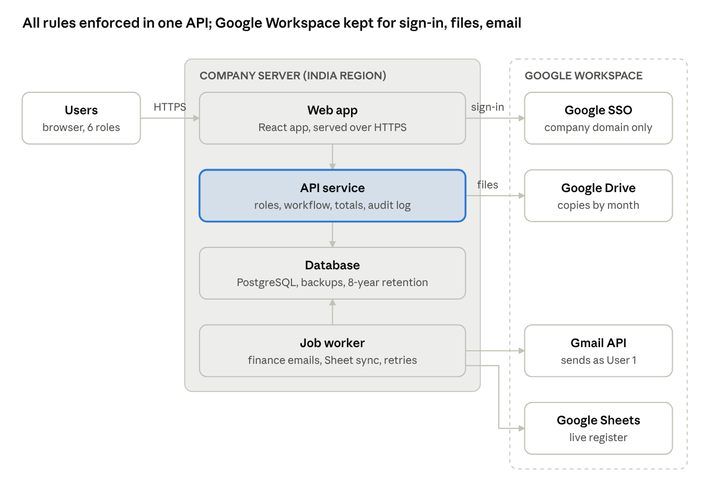
The API is the only component that writes data: it checks the role, recalculates totals and the L3 decision, and writes the audit log. The job worker sends finance emails and refreshes the Sheet from the database, so neither depends on a user's browser.
Integration | Pilot (today) | Target (company server)
Sign-in | Firebase Authentication with Google (domain check in rules) | Google OIDC, validated by the API (hd = mosaicwellness.in, verified email); company session cookie
Database and rules | Cloud Firestore + security rules | PostgreSQL + authorisation in the API, with an audit table
Invoice copies | Google Drive, written from the user's browser with their own access | Google Drive through a service account (Shared Drive), written by the API
Finance email | Apps Script web app running as User 1 | Gmail API with domain-wide delegation sending as User 1 (or an SMTP relay), from the job worker
Register | Google Sheets API, rewritten from the user's browser | Google Sheets API from the job worker after each change; Excel exports from the API
Hosting | GitHub Pages (front end) + Firebase (Google Cloud) | Company server or company cloud account in India; reverse proxy with HTTPS; CI/CD from the company Git

The full technical design (tables, API endpoints, Google setup, migration and deployment) is in docs/IT-README.md.

13. UAT acceptance criteria
The hosted version is accepted when all 18 scenarios pass with real users in a staging environment.
# | Scenario | Expected result
T-01 | Sign in with a personal Gmail account | Refused and signed out
T-02 | Sign in with a company account that has no role | "Access pending"; no data visible
T-03 | User 1 enters Taxable 1,000 + GST 180 with Total 1,280 | Cannot be saved: totals don't match
T-04 | User 1 enters the same vendor + invoice no. twice | Second invoice blocked as a duplicate
T-05 | User 1 adds a new vendor "Kalyan Movers" with GSTIN | Saved for everyone; GSTIN filled in later invoices
T-06 | User 1 validates without ticking "double-checked" | Validate button stays disabled
T-07 | User 1 sends 3 invoices across 2 categories | 2 batches created; Excel downloaded; copies in Drive under the service month folder
T-08 | Batch of ₹20,00,000 exactly | Route L1 → L2 → Finance (no L3)
T-09 | Batch of ₹23,60,000 | Route via L3; after L2 it goes to L3, not Finance
T-10 | L2 tries to act on a batch pending L1 | Refused by the server
T-11 | L1 approves 1 of 3 invoices, returns 1 with a reason, approves the rest | Batch moves to L2; total and route recalculated; returned invoice shows the reason to User 1
T-12 | L1 rejects the whole batch with a reason | All invoices Returned; User 1 can edit, re-validate and resend
T-13 | Final approval given | Finance email received from User 1's mailbox with the Excel and all PDFs; batch shows "Finance team emailed"
T-14 | Batch copies total about 40 MB | Main email + "part 2 of N" emails; main body unchanged
T-15 | Finance uploads a UTR template with 2 of 3 rows filled, one with TDS | Preview: 2 ready; amount paid = total − TDS; batch "Partly paid (2/3)"
T-16 | Upload with a 6-character UTR, a future date and an overpayment | Each row listed as a problem with its row number; nothing saved for those rows
T-17 | Finance enters the last UTR by hand | Batch becomes Paid and is locked; registers show UTR, TDS and amount paid
T-18 | Maker tries to edit an invoice pending approval | Refused by the server

14. Current status, known issues and open decisions
The pilot works end to end for upload, approvals, returns and payments. The finance email is built but not yet confirmed live: the setup test email had not arrived as of 26 Oct 2026.
Pilot status
Area | Status
Sign-in, roles, vendors, invoice capture, Drive filing | Live, tested by users
Approvals L1–L2, per-invoice approve and return | Live, tested by users (L3 tested in the emulator)
Database rules | 15 automated rule tests pass in the Firebase emulator, including a 100-invoice batch
App logic | 25 automated unit tests pass
Finance email | Built. Setup test email not yet received; diagnosis pending (mailer deployment or access)
UTR template and upload | Built and tested in demo mode; live UAT pending

Known limitations of the pilot (to fix in the hosted version)
- The batch total integrity check runs in the approver's browser. The server should recalculate totals itself (NFR-03).
- The Google Sheet is rewritten from the browser of whoever acted last. Someone without edit access to the Sheet causes a failed sync, which the next sync fixes. A server job is more reliable.
- The mailer runs as a Google Apps Script under User 1's account. If User 1 leaves, it must be set up again. A service mailbox or delegated sending is preferable.
- Deleting a draft, or replacing its copy, leaves the old file in Drive.
- Firestore limits each rule check to 1,000 evaluated expressions. This already caused one production defect (approvals refused), since fixed. A server-side backend removes this class of problem.
Decisions needed from IT
# | Decision | Options | Recommendation
D1 | Hosting | Company data centre (VM/Kubernetes) · company cloud account | Company cloud account in an India region
D2 | Database | PostgreSQL · SQL Server · keep Firestore | PostgreSQL 15+
D3 | File storage | Keep Google Drive (service account) · company object storage / file server | Keep Google Drive: users already work from the month folders
D4 | Finance email sender | Gmail API with domain-wide delegation (send as User 1) · shared mailbox (payments@) via SMTP relay | Domain-wide delegation, so it still comes from User 1
D5 | Pilot data | Migrate from Firestore · start fresh | Migrate (an export script is described in the IT README)
D6 | Go-live | Big bang · parallel run for 1 month | Parallel run for one month-end close

15. Glossary
Term | Meaning
Batch | The invoices of one expense category sent together for approval
L1 / L2 / L3 | Approval levels 1–3 (User 2, User 3, User 4)
Route | The approval path of a batch: L1 → L2 → Finance, or L1 → L2 → L3 → Finance
Return | An approver takes one or more invoices out of a batch and sends them back to User 1 with a reason
Reject | An approver sends the whole batch back to User 1 with a reason
Service month | The month the services were taken. It decides the Drive folder and can differ from the invoice date.
UTR | Unique Transaction Reference of a bank transfer (IMPS/UPI 12, NEFT 16, RTGS 22 characters)
TDS | Tax deducted at source; amount paid = invoice total − TDS unless entered otherwise
GSTIN | 15-character GST identification number of the vendor
SSO | Single sign-on with the company Google Workspace account
Mailer | The component that sends the finance email from User 1's mailbox (pilot: Google Apps Script)
Register | The Excel / Google Sheet listing of invoices, batches, approvals and payments

